***Lab No: 03***

***Slide no: 04***

1. select ENAME, JOB, DEPTNO from emp where job = 'CLERK';

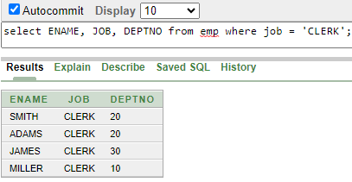

1. select ENAME, SAL, COMM from emp where SAL <= COMM;

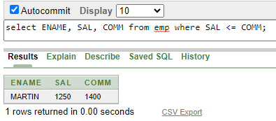

1. select ENAME, SAL from emp where SAL BETWEEN 1000 AND 1500;

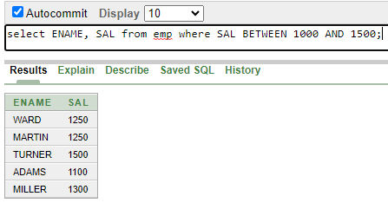

1. select EMPNO, ENAME, SAL, MGR from emp where MGR IN (7902, 7566, 7788);

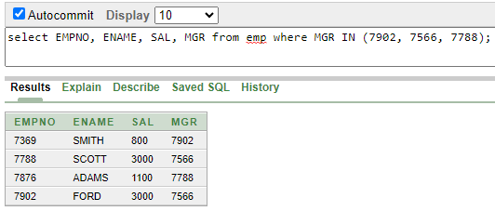

1. select ENAME from emp where ENAME LIKE 'S%';

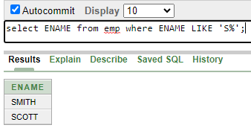

1. select ENAME from emp where ENAME LIKE '_A%';

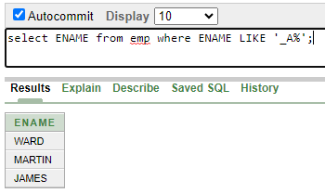

1. select ENAME, MGR from emp where MGR IS null;

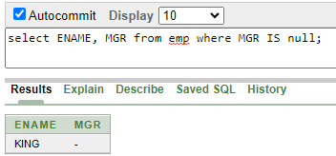

1. select EMPNO, ENAME, JOB, SAL from emp where SAL >= 1100 AND JOB = 'CLERK';

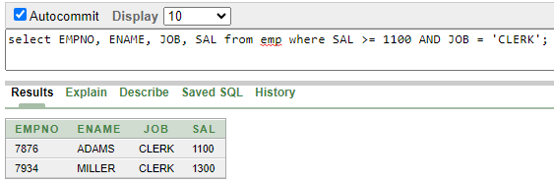

1. select EMPNO, ENAME, JOB, SAL from emp where SAL >= 1100 OR JOB = 'CLERK';

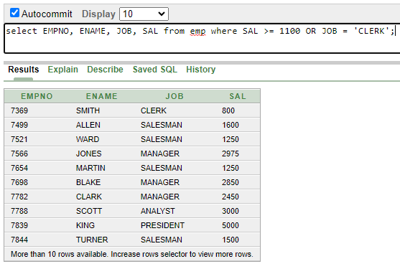

1. select ENAME, JOB from emp where JOB NOT IN ('CLERK','MANAGER','ANALYST');

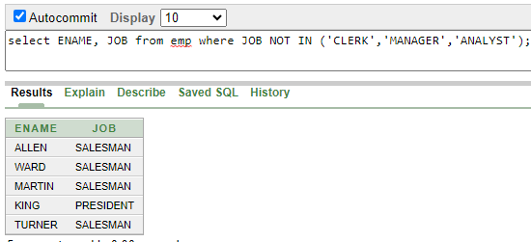

1. select ENAME, JOB, SAL from emp where (JOB='SALESMAN' OR JOB='PRESIDENT') AND SAL>1500;

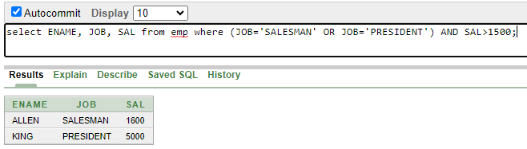

1. select ENAME, JOB, SAL from emp where (JOB='SALESMAN' AND JOB='PRESIDENT') OR SAL>1500;

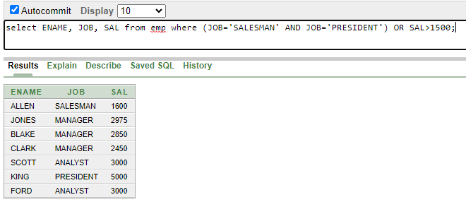

1. select ENAME, JOB, DEPTNO, HIREDATE from emp ORDER BY HIREDATE;

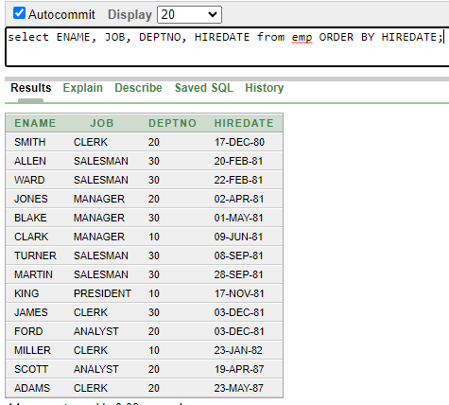

1. select ENAME, JOB, DEPTNO, HIREDATE from emp ORDER BY HIREDATE DESC;

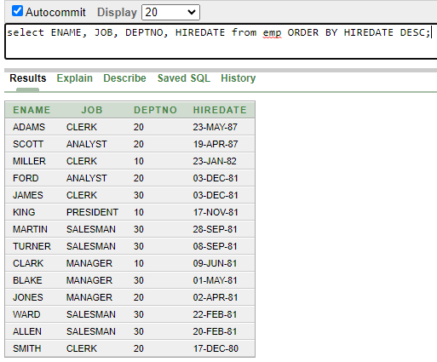

1. select EMPNO, ENAME, SAL*12 annsal from emp ORDER BY annsal;

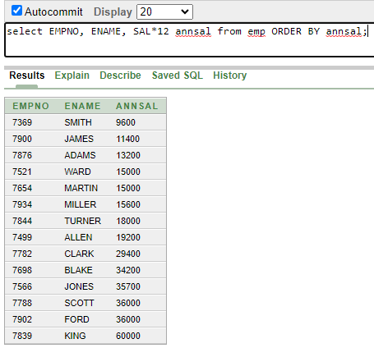

1. select ENAME, DEPTNO, SAL from emp ORDER BY DEPTNO, SAL DESC; 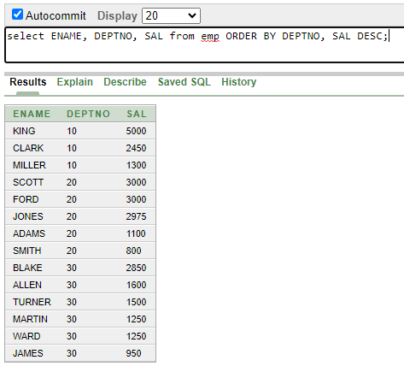

***Slide no: 06***

1. select EMPNO, ENAME, DEPTNO from emp where ENAME = 'blake'; 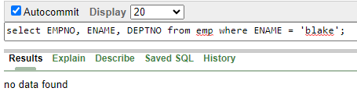
2. select EMPNO, ENAME, DEPTNO from emp where LOWER(ENAME) = 'blake'; 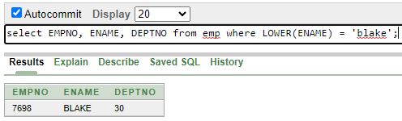
3. select ENAME, CONCAT (ENAME, JOB), LENGTH(ENAME), INSTR(ENAME, 'A') FROM emp WHERE SUBSTR(JOB,1,5) = 'SALES'; 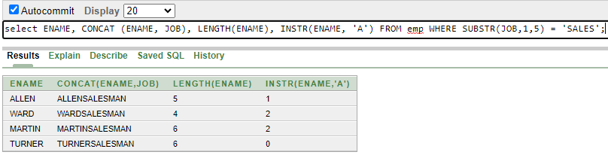
4. select ROUND(45.923,2), ROUND(45.923,0), ROUND(45.923,-1) FROM DUAL; 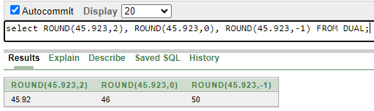
5. select TRUNC(45.923,2), TRUNC(45.923,0), TRUNC(45.923,-1) FROM DUAL;

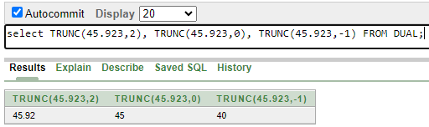

1. select ENAME, SAL, COMM, MOD(SAL, COMM) FROM emp WHERE JOB = 'SALESMAN'; 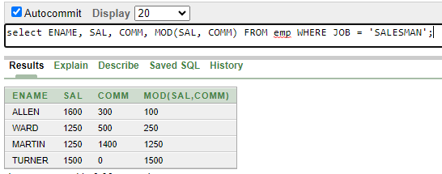
2. select ENAME, (SYSDATE-HIREDATE)/7 WEEKS FROM emp WHERE DEPTNO= 10; 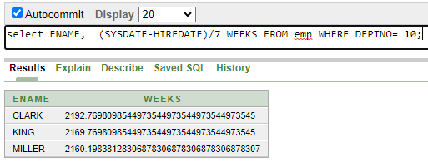
3. select ENAME, TO_CHAR(HIREDATE, 'fmDD Month YYYY') HIREDATE FROM emp; 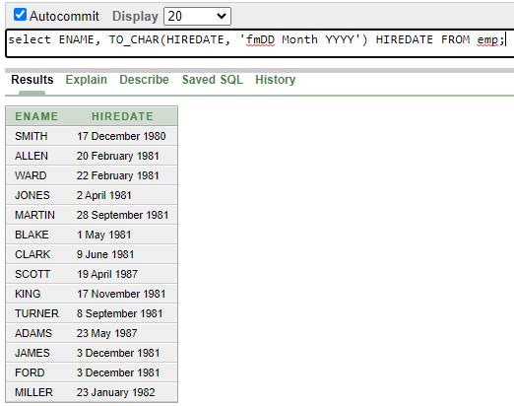
4. select TO_CHAR(SAL,'$99,999') SALARY FROM emp WHERE ENAME = 'SCOTT'; 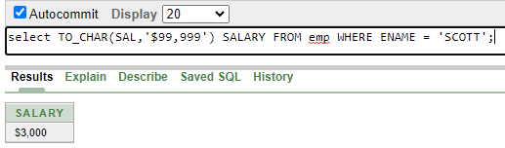
5. select ENAME, SAL, COMM, (SAL*12)+NVL(COMM,0) FROM emp; 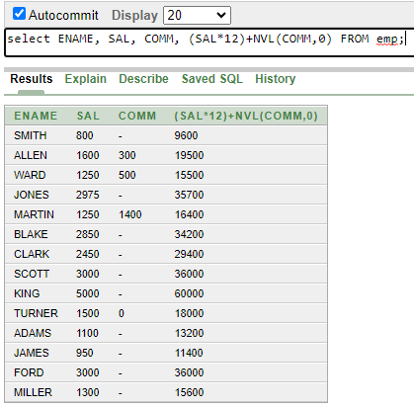
6. select JOB, SAL, DECODE(job, 'ANALYST', SAL*1.1, 'CLERK', SAL*1.15, 'MANAGER', SAL*1.20, SAL) REVISED_SALARY FROM emp; 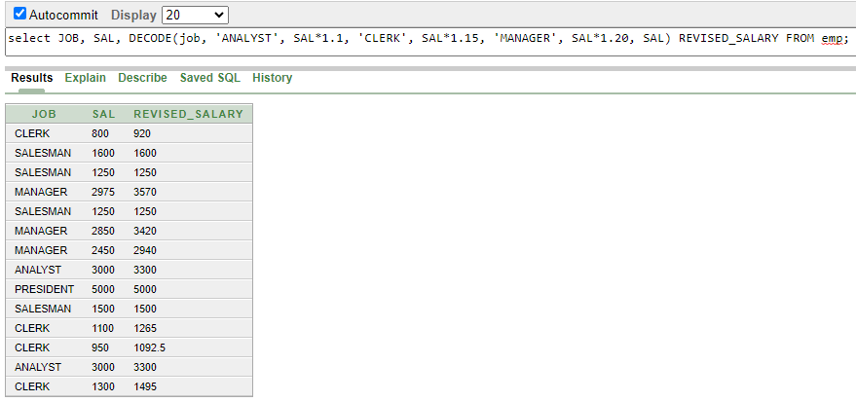
7. select ENAME, NVL(TO_CHAR(mgr),'No Manager') FROM emp WHERE MGR IS NULL; 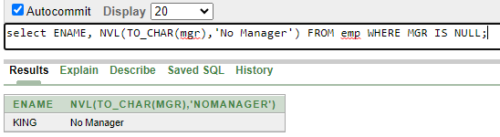

***Slide no: 08***

1. select AVG(SAL), MAX(SAL), MIN(SAL), SUM(SAL) FROM emp WHERE JOB LIKE 'SALES%'; 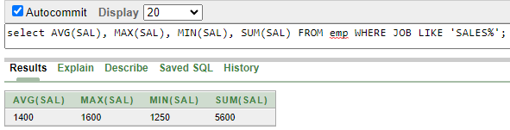
2. select MIN(HIREDATE), MAX(HIREDATE) FROM emp; 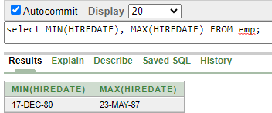
3. select COUNT(*) FROM emp WHERE DEPTNO = 30; 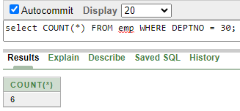
4. select COUNT(comm) FROM emp WHERE DEPTNO = 30; 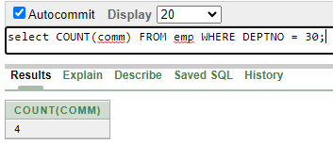
5. select AVG(comm) FROM emp;

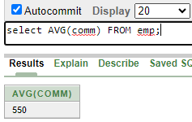

1. select AVG(NVL(comm,0)) FROM emp;

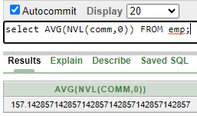

1. select DEPTNO, AVG(SAL) FROM emp GROUP BY DEPTNO; 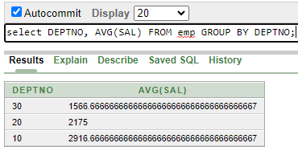
2. select AVG(SAL) FROM emp GROUP BY DEPTNO; 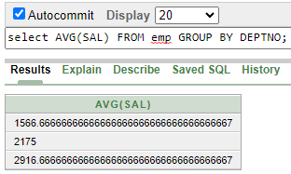
3. select DEPTNO, JOB, sum(SAL) FROM emp GROUP BY DEPTNO, JOB ORDER BY DEPTNO; 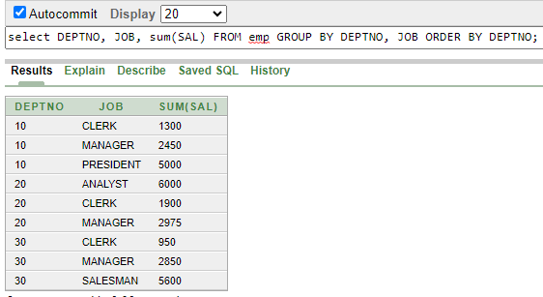
4. select DEPTNO, max(SAL) FROM emp GROUP BY DEPTNO HAVING max(sal)>2900; 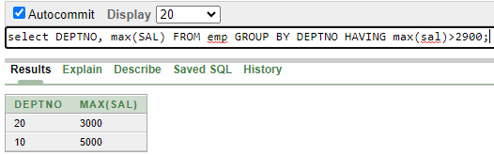
5. select JOB, SUM(SAL) PAYROLL FROM emp WHERE JOB NOT LIKE 'SALES%' GROUP BY JOB HAVING SUM(SAL)>5000 ORDER BY SUM(SAL); 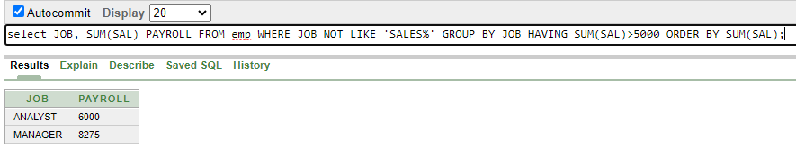
6. select max(avg(SAl)) FROM emp GROUP BY DEPTNO; 